GS-AC0X Series
Network Access Controller
The GS-AC0X is a series of powerful and stable access controllers, using the logical architecture design. The uplink and downlink adopt TCP/IP and wiegand communicate respectively. Its signal processed with special encryption and can be run offline. Anti-tampering function is also supported. | 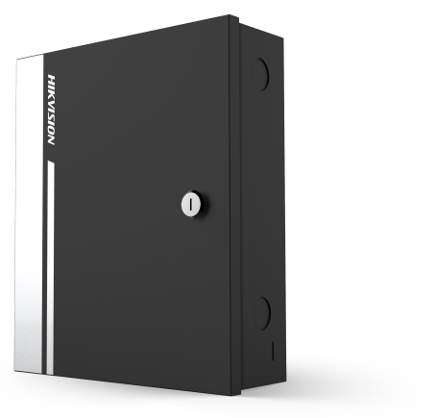
MODEL

GS-AC01 Single-door Access Controller
GS-AC02 Double-door Access Controller
GS-AC04 Four-door Access Controller

MAIN FEATURES

- 32-bit high-speed processor
- TCP/IP network communication, with self-adaptive network interface. The communication data is encrypted to ensure information security
- Supports Wiegand interface for accessing card reader. Wiegand interface supports W26/ W34 and is seamlessly compatible with third-party card reader
- Massive storage with 10, 000 cards information and 50,000 card swiping records
- Supports first card function, super card and super password function, online upgrade function and online remote control of the doors
- Supports various card types such as normal/ disabled/blacklist/patrol/visitor/duress/ super card, etc.
- Supports tamper-proof alarm for card reader, unsecured door alarm, forced entry door alarm, alarm for door opening timeout, duress alarm, and alarm for invalid card swiping attempts alarm, case in alarm and restore, insufficient storage alarm for offline event, network break alarm
- The recognition and storage of card number with maximum 20 digits
- Supports online and offline operating mode;
- Supports time synchronization via NTP, manual or automatic method
- Watchdog for device running status detection
- Data can be permanently saved when the access controller is powered off
- UL Listed
- High/low temperature resistant design(-20°C to + 65°C)

SPECIFICATIONS

Model | GS-AC01 | GS-AC02 | GS-AC04
Working Voltage | DC 12V
Power Dissipation  (with Load) | ≤50W | ≤100W | ≤100W
Power consumption | ≤3.5W (without Load)
Processor | 32-bit
RAM | 8M
Uplink Communication Interface | TCP/IP
Downlink Communication Interface | Wiegand (W26/W34)
Storage | Storage for 10, 000 Valid Cards Information and 50, 000 Card Swiping Records
LED Indicator | Power Supply Status, Communication Status, Abnormal Status
Built-in Clock | Yes
Accessible Card Reader | 2 Card Readers (Wiegand Interface) | 4 Card Readers (Wiegand Interface) | 4 Card Readers (Wiegand Interface)
Input Interface | Door Sensor × 1,  Exit Button × 1,  Case Input × 1 | Door Sensor × 2,  Exit Button × 2,  Case Input × 2 | Door Sensor × 4,  Exit Button × 4,  Case Input × 4
Output Interface | Lock Relay × 1, Alarm Relay × 1 | Lock Relay × 2, Alarm Relay × 2 | Lock Relay × 4, Alarm Relay × 4
Working Temperature | -20°C to +65°C (-4°F to +149°F)
Working Humidity | 10% to 90% (Non-Condensing)
Dimensions (L×W×H) | 285mm × 237mm × 69mm (11.22" × 9.33" × 2.72")
Certifications | UL Listed

